**LITERATURE SURVEY**

**By**

DINESH KUMAR.S

UDIT KUMAR.B

SYED FAROOK.M

BALAJI.N

ESWAR.R

# Hand Gestures Recognition Using Radar Sensors for Human - Computer Interaction

Abstract: Human-PC Connection points (HCI) manages the investigation of point of interaction among people and PCs. The utilization of radar and other RF sensors to foster HCI in light of Hand Signal Acknowledgment (HGR) has acquired expanding consideration over the course of the last ten years. Today, gadgets have inherent radars for perceiving and ordering hand developments. In this article, we present the very first audit connected with HGR utilizing radar sensors. We survey the accessible strategies for multi-space hand motions information portrayal for various sign handling and profound learning-based HGR calculations. We order the radars utilized for HGR as beat and persistent wave radars, and both the equipment and the algorithmic subtleties of every class is introduced exhaustively. Quantitative and subjective investigation of progressing patterns connected with radar-based HCI, and accessible radar equipment and calculations is likewise introduced. Toward the end, created gadgets and applications in light of gesturerecognition through radar are talked about. Constraints, future angles and exploration headings connected with this field are additionally talked about.

**Keywords:** hand-gesture recognition; pulsed radar; continuous- wave radars; human–computer interfaces; deep-learning for radar signals.

# Introduction

Lately, processing innovation has become implanted in each part of our day to day routines and man-machine cooperation is becoming unavoidable. It is broadly accepted that PC and show innovation will continue to advance further. An entryway which permits people to speak with machines and PCs is known as the human-PC interface (HCI) . Console and mouse and contact screen sensors are the conventional HCI approaches. In any case, these methodologies are turning into a bottleneck for creating easy to use interfaces . As opposed to this, human signals can be a more regular approach to giving a point of interaction among people and PCs. Short-range radars can identify miniature developments with high accuracy and exactness . Radar sensors have shown potential in a few exploration regions like presence recognition , important bodily function checking , and Radio Recurrence (RF) imaging reason . Choi et al. utilized a Super Wideband (UWB) Motivation Radar for indoor individuals counting.Similar research presented by used milli-metric-wave radar for occupancy detection. In addition to this, radar sensors have shown their footprints in handmotion sensing and dynamic HGR . The interest in radar-based gesture recognition has surged in recent years. Recently, radar sensors have been deployed in a network-fashion for the detection and classification of complex hand gestures to develop applications such as the wireless keyboard .

In the previously mentioned study , in-air development of the hand was recorded with three UWB radars and a following calculation was utilized to type 0-9 including digits in the air. One more review distributed by same writers introduced a constant letter set composing in light of the motions attracted front of two radars . A work introduced by Ahmed and Cho (2020) showed an exhibition correlation of various Profound Convolutional Brain Organization (DCNN)- based profound learning calculations utilizing different radars.

In view of the communicated signal, short-range radar sensors utilized for HGR can comprehensively be ordered as beat radar and ceaseless wave (CW) radar. This order has been embraced already in a few radarprelated survey articles for applications other than HGR . Beat radar, like Super Wideband Motivation Radar (UWB-IR), sends brief term beats, while persistent wave radar, for example, Recurrence Balanced Constant Wave (FMCW) radar, communicates and gets a ceaseless wave. Both these radars are generally utilized for HGR purposes.

# Understanding Human Gestures

Preceding making HCI, a comprehension of the expression "Signals" is significant. Scientists in characterized a signal as a development of any body part, for example, arms, hands and face to pass on data. This nonverbal correspondence comprises up to 66% of all correspondence among the people . Among the different body parts, hand signals are generally utilized for developing intuitive HCIs . 44% of studies zeroed in on creating HCIs utilizing hand, different hand and finger developments. Hand signals are a significant piece of non-verbal correspondence in our everyday existence, and we widely use hand motions for correspondence purposes, for example, pointing towards an article and passing on data about shape and space. Using hand developments as an info source rather than a console and mouse can assist individuals with speaking with PCs in more simple and natural manner. HGR frameworks have additionally found numerous applications in conditions which request contactless collaboration with apparatus, for example, emergency clinic medical procedure rooms to forestall the spread of infections and microbes. Subsequently, contactless HCI can be a protected method for man-machine cooperation in epidemiological circumstances like MERS and the new and progressing

Coronavirus episodes.

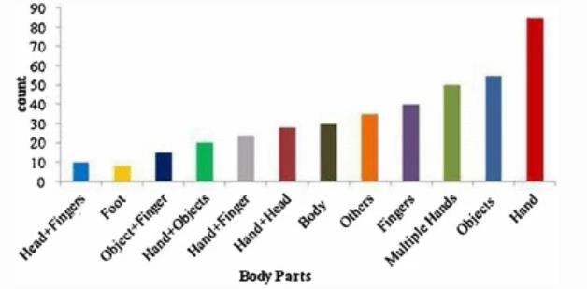

**Figure 1**. Usage of different body parts to make a human– computer interface (HCI)

# Hand-Gesture Based HCI Design

The framework outline of hand-signal based HCI advancement. Initial, a brain spike is delivered in the mind, which creates a sign that outcomes in a deliberately movement of the hand. Different investigations have attempted to decipher the mind cue comparing to hand development and these signs should be visible through electrocorticography . To recognize the hand developments, a few sensors exist, like camera, profundity camera, and radio sensors. The sign at the result of these sensors is investigated utilizing reasonable algorithmic procedures to recognize a predefined hand motion. Analysts have either utilized signal-handling based strategies , or AI and profound learning-g-based procedures . After effectively perceiving the ideal hand-developments, these motion based frameworks can be utilized to fabricate various applications like gaming and robot regulator. many sensors are accessible for obtaining signals against the performed hand motion, and radar sensor is one of the up-and-comer arrangements. Generally, optical sensors (camera), and wearable sensors (gloves) are generally utilized. These sensors can be delegated wearable and nonwearable

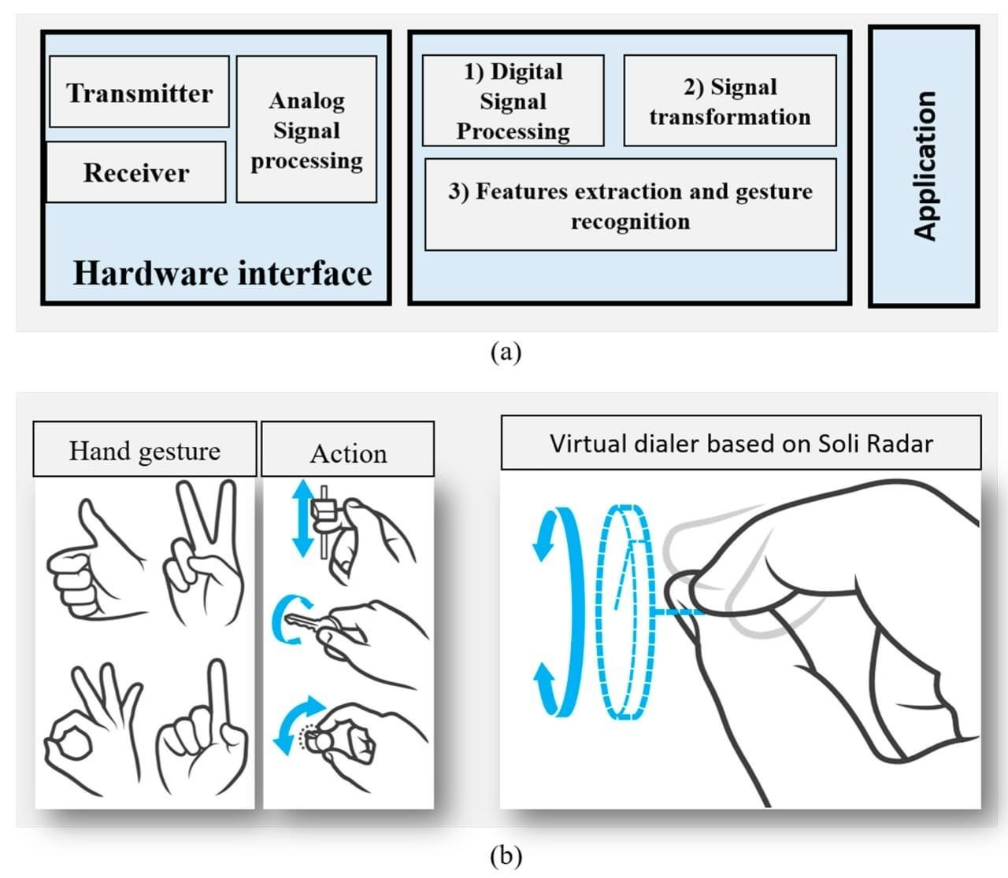

line of hand gesture recognition (HGR)-based HCI design. User performs pre-defined hand gestures, the performed gesture is captured with different sensors, sensor data are digitized and formatted in an appropriate way and finally, the devices are controlled.

The examination of existing wearable and non-wearable (remote) sensors utilized for perceiving hand motions. It very well may be seen that the two kinds of innovation have their own assets and shortcomings and can be chosen by the necessities of the application in thought. Both the radar and the cameras give a remote connection point to signal acknowledgment. Radar sensors have a few benefits over camera-based acknowledgment frameworks for motion acknowledgment. Radar sensors have a few advantages over camera-based acknowledgment frameworks . Radar isn't impacted by lightning condition.After data acquisition, the next step is processing the data and recognizing hand gestures. This includes data representation, useful features extraction, and classification. The classification can be performed by using signalprocessing approaches, traditional machine- learning approaches or deep-learning approaches . One of the earliest uses of radar for gesture recognition was introduced in 2009 . This research primarily focused on activity classification along with gesture classification. Zheng et al. in 2013, presented hand gesture classification using multiple Doppler radars. In the beginning, for detection and recognition, researchers relied heavily on techniques based on the analysis and manipulation of the received radar signal and, later, the focus shifted towards machine-learning- and deeplearning- based classification techniques .The overall workflow of HGR through radar.

In view of the writing study, it was seen that the undertaking of radar-based HGR can be additionally arranged into three different sub-assignments:

1. Hand-signal development securing, where one of the accessible radar advancements is picked.
2. Pre-handling the got signal, which includes pre-sifting followed by an information designing which relies upon stage 3. For instance, the 1D, 2D, and 3D profound Convolutional Brain Organization (DCNN) will, separately, expect information to be in a 1D, 2D or 3D shape.
3. The last step of hand-signal characterization is like some other grouping issue, where the information are ordered utilizing a reasonable classifier.

# Main Contribution and Scope of Article

This article gives a far reaching study and examination of the accessible writing for HGR through radar sensors. Beforehand, Li et al. examined several examinations connected with the utilization of radar for motion acknowledgment while looking into uses of versatile radars. In any case, to the best of the writers' information, there is no audit article for HGR through radar sensor. Specialists have recently surveyed camera-and optical-sensor based HGR frameworks just . The fundamental commitments and extent of investigation can be characterized as follows:

* We have examined different accessible radar innovations to understand their similitudes and contrasts. Every one of the viewpoints connected with HGR acknowledgment, including information obtaining, information portrayal, information preprocessing and grouping, are made sense of exhaustively.

* We made sense of the radar-recorded hand-signal information portrayal methods for 1D, 2D and 3D classifiers. In view of this information portrayal, subtleties of the accessible HGR calculations are talked about.

* At long last, subtleties connected with application-arranged HGR research works are likewise introduced.

* A few patterns and study examinations are likewise included.

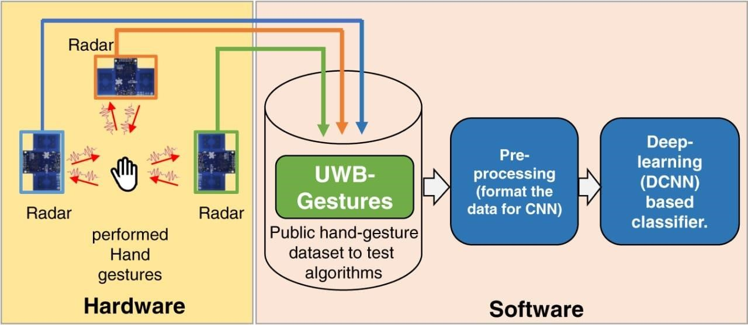

# Conclusion

An immense upsurge and quick progression of radar-based HGR was seen in the previous ten years. This paper checked on a portion of the examination connected with HGR applications utilizing radars. At present, the specialists depend intensely on the economically accessible radars made by tech organizations like Infenion, Novelda and Texas Instrument. With these frameworks being on chips, much consideration has been paid to foster the motion location and acknowledgment calculations. Lately, interest is moving from signal-handling based HGR calculations to profound learning-based calculations. Especially, variations of CNN have shown promising materialness. Despite the fact that radar sensors offer a few benefits over the other HGR sensors (i.e., wearable sensors and cameras), the reception of radar-based HGR in our regular routines is as yet lingering behind these contending advances. Consideration should be paid to scaled down equipment advancement and constant acknowledgment calculations' turn of events.